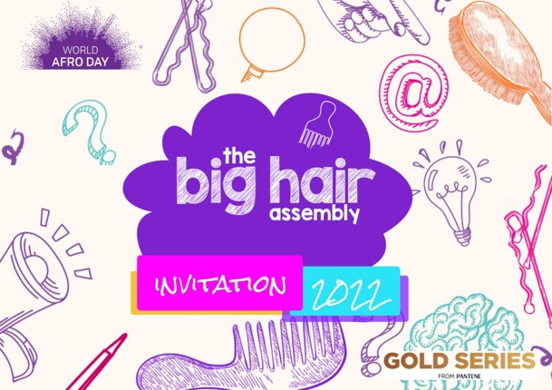

Dear Headteacher, Principal, Teacher,

During these challenging times, we know how important it is to warmly welcome pupils back to school and start the new academic year on a positive note.

We are pleased to invite you to the Big Hair Assembly at 1:30pm BST, Thursday 15th September 2022. This free online celebration of equality and diversity forms part of a global movement to turn negative attitudes towards Afro hair into a positive force for inclusion and is a great way to inspire an inclusive school environment.

Across the UK, one in six children with Afro-textured hair experience hair discrimination in school. The UK government have recently stated that they also want to tackle this issue (Inclusive Britain Report). We continue to address this through research and events. The Big Hair Assembly is an educational event designed to empower students, celebrate diversity and encourage a positive school culture.

During this event, students of all ages and backgrounds will be inspired by hosts Dr Zoe Williams and Yewande Akinola MBE, plus excellent guests from various STEM disciplines. Dr Rolanda Wilkerson, Chemist; Dr Youmna Mouhamad, Engineer; Karlton Charles, Oxford Maths offer, De-Shaine Murray, Neuroengineer and Youth Presenter Paolo Ben Salmi, engineering. They are all joining together to share their passion for STEM and Afro hair equality for the next generation. The event will culminate with a musical finale.

You can sign up your school on our website here. You can also follow us on our social channels insta and twitter @worldafroday or on Facebook to be part of the change. Award-winning, World Afro Day® is an annual day of change, education and celebration of Afro hair, culture and identity. The annual event was founded 15th September 2017 and is endorsed by the United Nations Ofﬁce of the High Commissioner for Human Rights. We raise awareness about Afro hair discrimination and create positive solutions.

We hope that you can be a part of this global momentum.

Warmest Regards,

Michelle De Leon Denese Chikwendu
CEO and Founder, World Afro Day Director, World Afro Day

