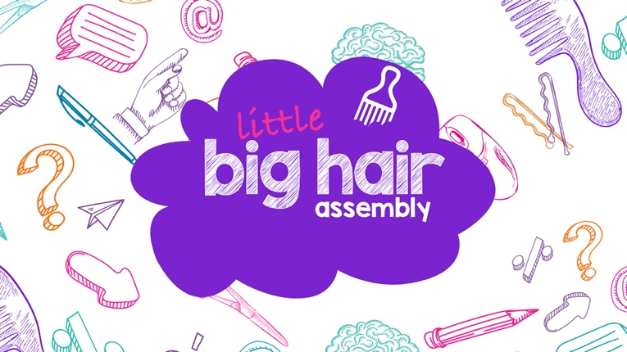

Dear Headteacher, Principal, Teacher,

We are pleased to invite you to host your own “Little Big Hair Assembly” on the 15th September 2022. This will also mark the 6th anniversary of World Afro Day®. This is the sister event to the livestream Big Hair Assembly and 2021 was the inaugural year for the “Little Big Hair Assembly.” There were 222 little assemblies, hosted all over the world too. The response last year was very encouraging and this year we have a new STEM theme. We include a free format, activities, visuals and resources for you to host your own little assembly, suited to younger children aged 4-9 years. We hope that you will share the best from your day with us and the nation and tag our social channels @worldafroday

Children 10 years and over are welcome to join the livestream Big Hair Assembly at 1:30-2:30pm BST, Thursday 15th September 2022. Hosts Dr Zoe Williams and Yewande Akinola MBE, plus excellent guests from various STEM disciplines. Dr Rolanda Wilkerson, Chemist; Dr Youmna Mouhamad, Engineer; Karlton Charles, Oxford Maths offer, De-Shaine Murray, Neuroengineer and Youth Presenter Paolo Ben Salmi, engineering. They are all joining together to share their passion for STEM and Afro hair equality, for the next generation. The event will culminate with a musical finale.
.
Across the UK, one in six children with Afro-textured hair experience hair discrimination in school. The UK Government have recently stated that they also want to tackle this issue (Inclusive Britain Report). We continue to address this through research and events, which are supported by Britain’s major education unions: ASCL, NAHT, NASUWT, NEU and Voice Community. The Big Hair Assembly is an empowering event for people from all backgrounds, joining together in a celebration of Afro hair, identity and equality.

You can sign up your school on our website here. This includes a free resource pack featuring author Tola Okogwu, whose new children’s book will become a Netflix film. You can also follow us on our social channels insta and twitter @worldafroday or on Facebook to be part of the change.

Award-winning, World Afro Day® is an annual day of change, education and celebration of Afro hair and identity. The annual event was founded 15th September 2017 and is endorsed by the United Nations Ofﬁce of the High Commissioner for Human Rights. It raises global awareness about Afro hair discrimination and creates positive solutions.

We hope that you can be a part of this positive momentum.

Warmest Regards,

Michelle De Leon Denese Chikwendu
CEO and Founder, World Afro Day Director, World Afro Day

